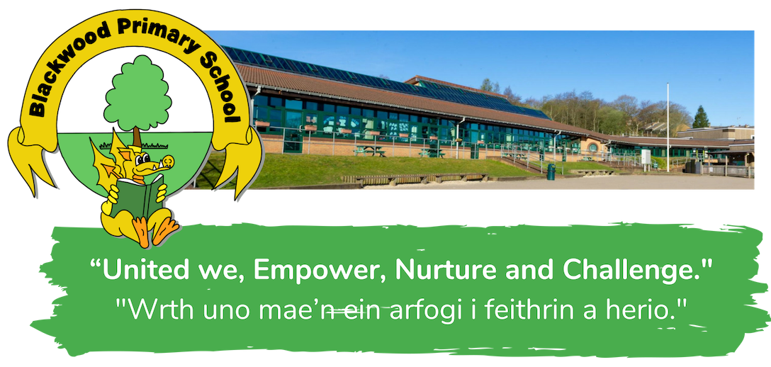
Year Group Booklet

Reception

Autumn Term 2020

Stay Safe, Stay Learning

If you have any queries or concerns please email: mainoffice@blackwoodprimary.org

Contents

- Introduction
- On entry to and exit from the school/ classroom
- Classroom Environment and routines
- Use of the toilets
- Communication

- Introduction
The Reception Team would like to take this opportunity to welcome you back to Blackwood Primary School, and to our Reception unit.
Within this booklet you will find a range of helpful information about our new school environment, important information steps that have been taken to ensure that with your child’s wellbeing and safety are paramount.

- On entry to and exit from the school/ classroom

- Children and parents/carers arrive at the car park gate: Class 1(Miss Sims) at 8.50am, Class 2 (Mrs Cooper) at 9.00am.
- Parents will leave the children in the capable hands of the reception staff until being picked up at the car park gate. Please note times below:
Sunbeams (9-12) and Stars (8.50-11.50): Thursday 3rd September
Rainbows(9-12) and Moonbeams (8.50-11.50): Friday 4th September
Sunbeams (9-3) and Stars: Monday 7th September (8.50-2.50) and Wednesday 9th September
Rainbows (9-3) and Moonbeams(8.50-2.50)Tuesday 8th September and Thursday 10th September
- From the week beginning 14th September 2020 it is compulsory for all children to attend school from Monday to Friday in their normal registration class. Class 1 (Miss Sims) 8:50 - 14:50 and Class 2 (Mrs Cooper) 9:00 - 15:00.

Entry routine:
- A member of staff will greet and support the children to use hand sanitiser and direct them to their classroom door.
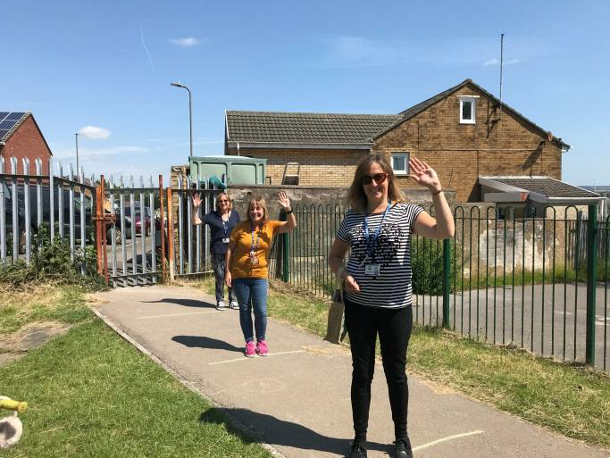
- Children will be welcomed by the teacher from their bubble at their classroom entrance.
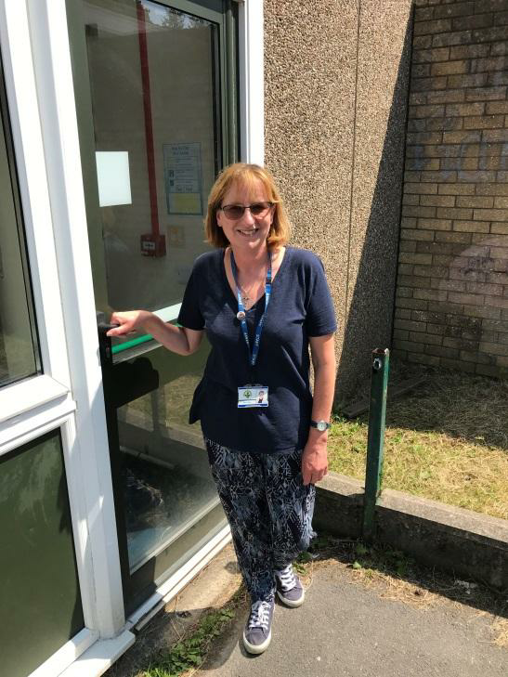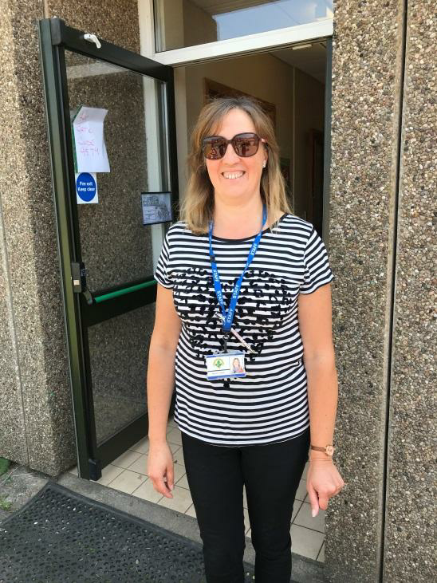
Miss Sims Mrs Cooper
- Children will store packed lunch and snacks, coats and other weather appropriate items in their cloakroom areas
- Children will wash hands on entry and will be directed to their work station.

Exit routine
- Children will gather all belongings and line up.
- Children will wash their hands before leaving school.
- At the end of the session a member of staff will greet parents and call for each child.
When your child gets to you we would ask you to move away from the gate as quickly as possible to allow the next class to exit safely.

- Classroom Environment
During daily sessions, children will have a variety of activities to engage them throughout the day. There will be an emphasis on emotional, mental and physical well-being and an opportunity to develop relationships with friends, peers and trusted adults. We will be undertaking lots of individual and small group activities to find out each child’s strengths and areas for development.
- Children will have access to a variety of equipment; they will wash hands before and after use.
- At the end of the day any shared resources will be cleaned.

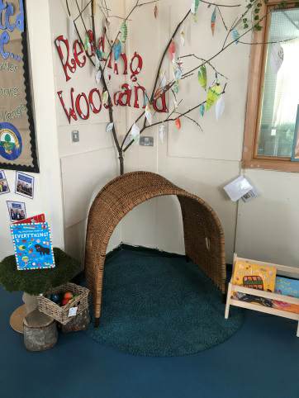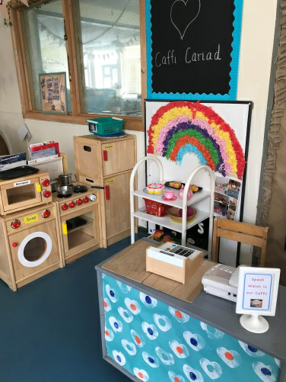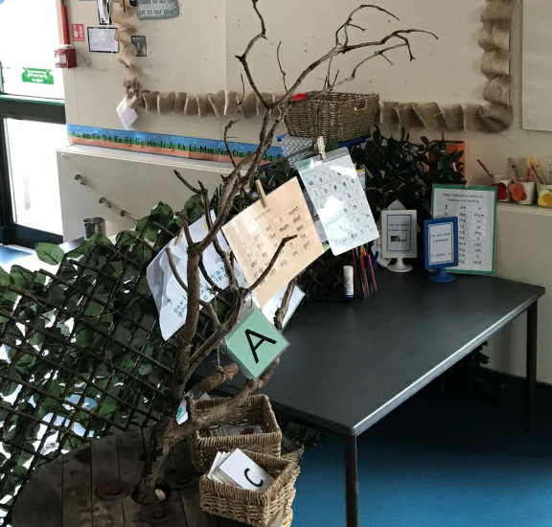
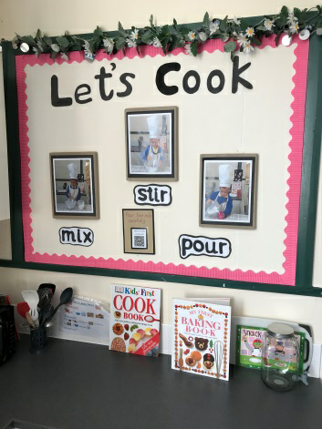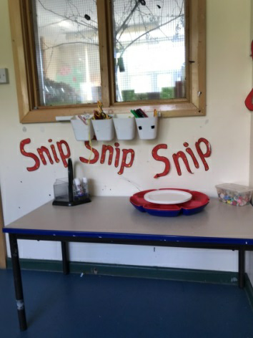
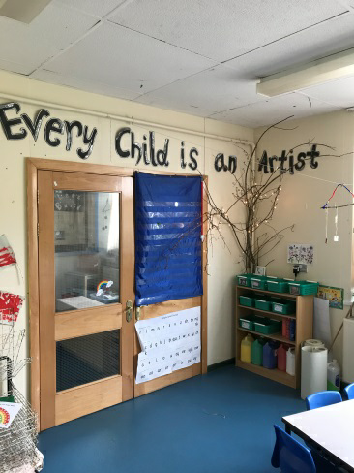
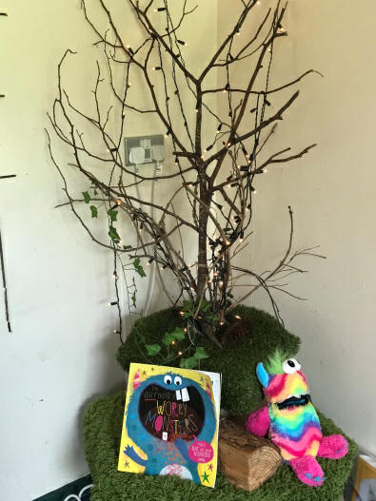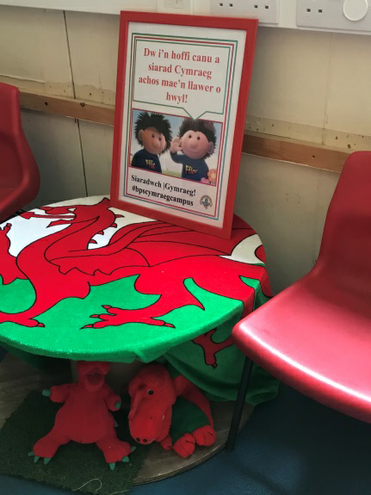

Universal Provision

- Universal Provision forms the foundation for all other provision or support made available to children in Blackwood Primary School. Provision includes strategies, resources and the environment that supports teaching and learning.
- Children will be supported through their emotional and wellbeing transition into Reception through a range of strategies and resources listed below.

Emotional regulation:
5 Mindful Calm down breathing techniques
5-4-3-2-1 Grounding Exercise
Calming Strategies
Emotional Charts
Self Regulation Basket/Box
These strategies and resources can be used at home before and during
their time in class

Mindful/ Calm down breathing techniques:

It's easy to remind a child to take some deep breaths while a meltdown is imminent, but most kids do quick, shallow breaths. Unfortunately, shallow breaths don't do much to regulate our bodies.

Instead, we need to take long, deep breaths from the bottom of our bellies to really calm our bodies down.

Long, mindful breaths.

Rainbow Breathing:

This breathing technique is all about stretching up and out as you paint the colours of the rainbow across the sky. Here's how to do rainbow breathing:
- Breathe in as you slowly raise both arms straight up above your shoulders.
- Hold your breath and arms up for 3-5 seconds.
- Breathe out as you slowly lower your arms until they are level with your shoulders.

Elevator Breathing
Imagine you are in the lobby of a building and you spot an elevator. You're going to get into the elevator and ride it all the way up to the top floor and then ride it all the way back down. Here's how to do elevator breathing:
- Sit tall in a chair or sit cross-legged on the floor and place one hand, with palm facing down, on your lap.
- Stack your other hand, with palm facing down, on top of your other hand.
- While breathing in slowly, raise your top hand up to your chin as if it is an elevator.
- Hold your breath and your hand, imagining people exiting the elevator, for 3-5 seconds.
- Breathe out as you slowly lower your hand back to its original starting position.

Take Five Breathing
- Make a fist.
- Breathe in and out.
- Stick out your thumb.
- Breathe in and out.
- Stick out your index finger.
- Breathe in and out.
- Stick out your middle finger.
- Breathe in and out.
- Stick out your ring finger.
- Breathe in and out.
- Stick out your pinky/little finger.

Snake Breathing
Get ready to hiss like a snake:
- Breathe in.
- Hold for 3-5 seconds.
- Make a hissing sound as you breathe out.

Square Breathing
- Use your index finger to quickly draw a square in the air while breathing in slowly.
- Draw the same square again while breathing out slowly.
5-4-3-2-1 Grounding Exercise
This is a very simple and extremely effective grounding exercise. It will distract a child from the anxiety trigger, help focus on the present moment and relax.
Ask the child:
Name 5 things you can SEE in the room
Name 4 things you can FEEL
Name 3 things you can HEAR
Name 2 things you can SMELL right now
Name 1 thing you can TASTE.

Calming Strategies

- Divert attention: change the subject, sing a song, pay attention to something else

- ‘Change to scene’ - take outside

- Listen to soothing music/sounds (whales, calming music, etc)

- Show calming images/videos

- Talk to someone - teacher TA
- Use one of the 5 mindful breathing techniques - see cards

- Use the ‘Grounding’ exercise - see sheet

- Use items in the ‘self regulation’ basket - one in every class

- Express emotion using an emotion chart to open discussion about feelings.

Emotional Charts

Emotions Charts are widely used because they provide a simple way to assist
kids in:
- identifying emotions
- labelling emotions
- expressing feelings
- grading the intensity of those feelings
Lots of children have all or nothing thinking. They see things as black and white. For example, they are either happy or sad, energetic or tired. Some children can struggle to voice when they are in the middle ‘grey’ areas’ of feelings and emotions. In offering an open dialogue with a child where they are able to report their thoughts and emotions on a scale can be a good opportunity to develop their deeper thinking. You can modify scales to compliment a child’s understanding, they may prefer pictorial scales or numerical scales.
Self Regulation Basket/Box

Self regulation baskets/boxes will have a range of multi sensory resources that children can access throughout the day. Resources will be cleaned and sanitised accordingly.
- Use of the toilets
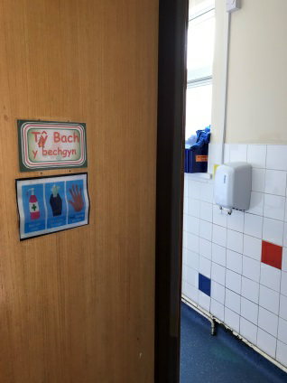
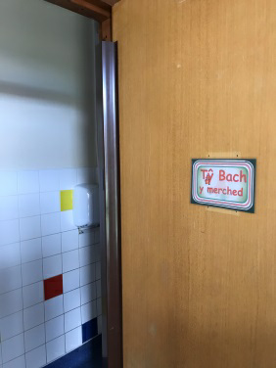
We have toilets for girls and separate toilets for boys. The boys have a urinal as well as a cubicle.

As usual children will be encouraged to wash their hands after using the toilet.

- Communication

- School Website - www.blackwoodprimary.org
- Follow us on Twitter:
Main school - @Blackwood_PS
Reception twitter - @ReceptionBPS
Forest Schools - @ForestSchoolBPS
Health & Wellbeing - @WellbeingBPS

- Welcome Video
Please visit the school website to see the Welcome Video

If you have any queries or concerns whilst the school is closed, please email: mainoffice@blackwoodprimary.org

